# Lab 9: Rock Paper Scissors Variation Game

Academic Honesty

* The work you turn in is to be your work, not copied from someone else, from the web, or generated by a program.
* Never allow anyone access to your files.
* Never give anyone your password.
* Never share your USB memory or email your files to anyone else.
* Never give anyone a printed copy of your file or an electronic copy.
* Never allow anyone to copy your work.

Purpose

This lab will let us practice picking a random item from an array, a loop, a series of if..elif…else statements, and the “and” logical operator

## Functionality

* You will be creating a variation on the game rock, paper, scissors.
* This game is called Robot, Pirate, Ninja, Monkey, Zombie
* You will introduce the game, and then ask the user to pick a character
* The computer will pick a random character from the list
* Based on the following rules, you will indicate if it’s a tie, or if someone won:
  + If both players pick the same character it’s a tie
  + Otherwise base a victory on the picture below

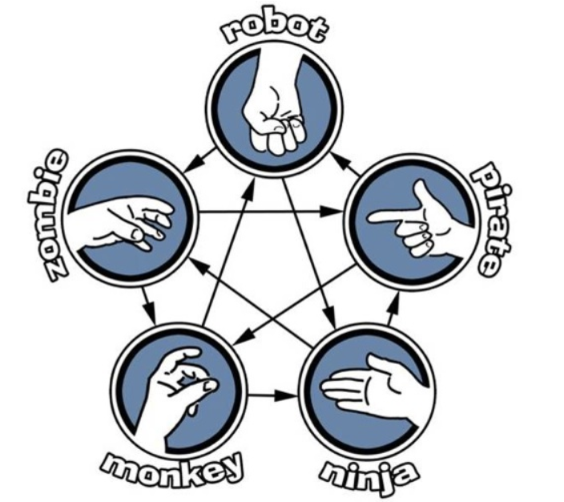

* When the game is done, you will ask the user if they would like to keep playing or if they are done.
* Lastly, when they say they no longer want to play anymore, indicate how many times the user one, and how many times the computer one.

## Implementation

* Create an array of characters
* Introduce the game
* Create a loop that will continue to play until the user indicates they no longer want to play the game. In the loop:
  + Use the random generator, and random.choice to pick the computers character.
  + Ask the user for their character, make sure you convert it to lower case and get rid of whitespace for comparison.
  + If they guess the same character as the computer, tell them it’s a tie, otherwise let them know who won based on the picture above
  + If they entered invalid input, let them know
  + Then ask if they would like to play again… If they enter “Y”, or “y” then continue looping, otherwise say “goodbye”
* Lastly, when they are done playing the game, tell them how many times they one, and how many times the computer did.

## Sample Program

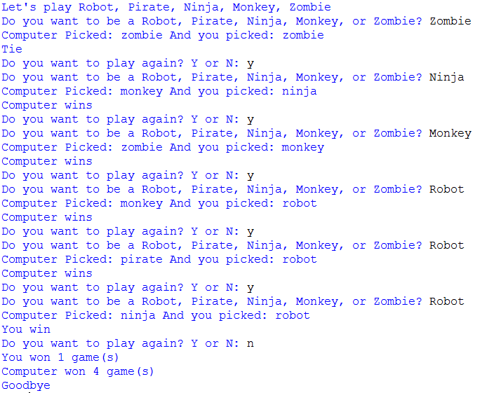

## Submitting your files

* Copy your .py file and move it to your X:\101Labs directory for grading.
* Make sure your file is named Lab9XY.py where XY are your initials
* Print your code, and submit it to your lab instructor at the beginning of your next lab class.

## Grade Breakdown

|  |  |
| --- | --- |
| **Points** | **Expectation** |
| 10% | Comments, listing program, your name, and explaining the code |
| 30% | Correctly setup the loop |
| 15% | Correctly generate random animal |
| 15% | Gather user input |
| 30% | Correctly execute game logic |